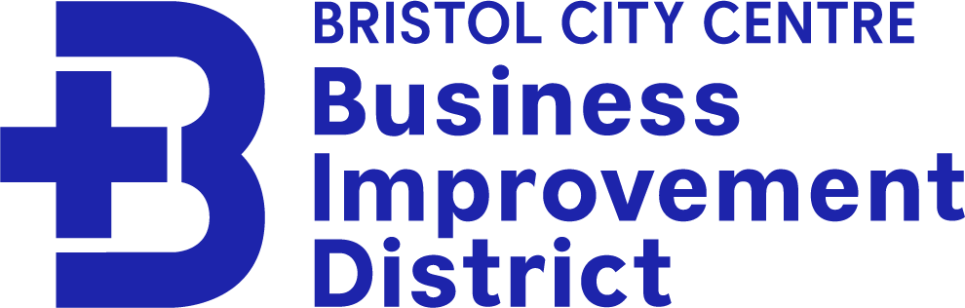

Advisory Board Agenda
Tuesday 11th January 2021 - 10:30 – 12:00

Zoom: https://us02web.zoom.us/j/81662368685?pwd=ajBTZTZoWWFRemNEZUpSUStNa2VSdz09
Meeting ID: 816 6236 8685 / Passcode: 017023
Agenda

- Welcome and apologies

- Quarterly Performance Report (October to December) questions/ comments.

- Project updates:
- Christmas activity
- Belly Laughs
- Bristol Light Festival 2022
- 5th grant from TAP for Bristol
- City Centre BID PCSO

- Budget/ billing update for 2021/22.

- Renewal ballot September 2022

- Future meeting dates (January / March / June / September)

- Other urgent business.

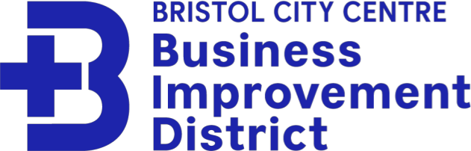
Advisory Board Minutes
Tuesday 11th January 2021 - 10:30 – 12:00 Zoom Meeting
Attendees: Anna Farthing (Chair), Vicky Lee, Keith Rundle, Fran Inman, Nathanial (Nat) Naylor, David Foley, Paula Ratcliffe, Trish Brown, Matt Birch, James Durie, Andy Pick, Ella Charles
Apologies: James Woollam, Ben Phillips, Josh Harrison, Councillor Farah Hussain, Rob Cheeseman, Helen McGee, Alex Gregory.
Standing Down from Advisory Board: Jackie Goldstone, Mark Sheridan
1) Project updates:
Cleansing:
- - Operating as normal. Reports are put together monthly and quarterly. The teams
are supporting lots of Levy Payers, responding to specific requests.
- - There have been increasing figures of graffiti. Nat and Avon and Somerset Police are
picking up this up alongside the Council. There is a team getting together to focus on
graffiti in the city centre specifically. Tap for Bristol:
- Reached fundraising goal, for Caring for Bristol. At Christmas they worked to supply food and comfort. This is an important part of BID work and needs to be communicated to businesses. Aim to work on providing case studies of people’s lived experience.
Bristol Light Festival:
- Planned to go ahead on 1-6th March 2022 with Covid contingency plans. All finances
have been safeguarded through contracts and postponement is an option if required. It is unlikely that postponement will need to happen. Have been successful on Arts Council England Grant of £71,250. Partnering with Redcliffe and Temple BID, there will be 14 art works in total, 9 in Bristol City Centre. Spread out geographically which encourages people to move around city and support businesses.
Policing:
- Nat has been out talking to Levy Payers, visited roughly 60 businesses in 40 days.
Safety projects:
- - Water Safety: Launched in Summer 2021, working with Fire Service, to reduce water
related incidents. Looking to do campaign refreshes this year. Plaster supported with
marketing of this campaign.
- - Drink Spiking: very well received campaign, influenced national police policy. A city-
wide campaign, focusing on the perpetrator rather than victim.
- - SWaN (Safety of Women at Night): Aim to train more than 20 venues, city wide
campaign, partnered with police and council.
- - Received an application for a BID Police officer, interviewing later this week. Stats of
water related issues, less. Related to campaign not sure, but not as many.
A37/A4108 proposal:
- A lot of traders against these proposals on Park Street. They are concerned about
losing trade, and the increase of pollution in other areas of city. The BID is being conduit between these retailers and the Council. A survey had been sent out to find out the views of all traders, now at 44 responses - 75% against the proposal.
Christmas 2021:
- - Something Special from Somewhere Special – encouraged members of public visit to
City Centre and to support businesses. Received welcome back grant from council (£2400) which funded shopping events on Park Street with street performers and choirs. This built BID profiles, website reaches have increased as a result.
- - Christmas Adventures - 12 projections (of 24) in City Centre area including Cabot Circus and SS Great Britain
- 2) Budget/ billing update for 2021/22.
  - - Discussed Levy income, higher than expected. The projected figure is based of previous year’s collections and knowledge of circumstances.
  - - It has been noted that the Council are not providing payment details to BID. As a result, we are unable to see who has paid and who hasn’t. This is a new move from the Council and not normal. The Council have the rationale that it would be a breach of GDPR and business confidentiality. This information is crucial for delivering support to Levy Payers, especially for upcoming renewal vote.
- 3) Renewal ballot September 2022
  - - Working a on a prospectus for the next 5 years to show case ideas and business plan. Vicky would like to work with as many board members, and businesses to discuss views and ideas for the future. Would like to consult with Levy Payers as much as possible.
  - - Campaign will start in July. Voting period in September.
  - - Voting: need to have 1 more than 50% of the number of Levy Payers vote in favour.
Need to have £1 more than the rateable value across the area.
  - - To have credibility, need roughly 35/40% voting. The ballot launches on 1st
September running to 29th September. Results produced on 30th September.
- 4) Future meeting dates (January / March / June / September)
  - - Vicky will put forward Poll for next meeting date. The meeting will be scheduled for early March.
  - - There will be a meeting in September - ahead of the renewal
  - - Potential for Subgroups - to discuss and points of interest – to include renewal work.
- 5) Other urgent business
Keith’s Post:
- Keith has the intention to leave on 28th March (last working day 24th March). The
selection process to find a suitable replacement was unsuccessful. As a result, the process was reviewed. Keith feels that each BID has a lead that does not require supervision. Management can continue to be completed by the Advisory Board and the Directors at Visit West. Therefore, have made the decision not to find a replacement for Keith at this point.
Queen’s Jubilee:
- Vicky attended a meeting before Christmas, hosted by the Cathedral where events
and activities were brainstormed. There is due to be a follow up meeting at the end of this month. The BID is keen to engage and there is budget for this. A good
opportunity for the BID and Levy Payers to pay a part in collaboration across the whole city.

